The merchandise company that I chose was Revionics

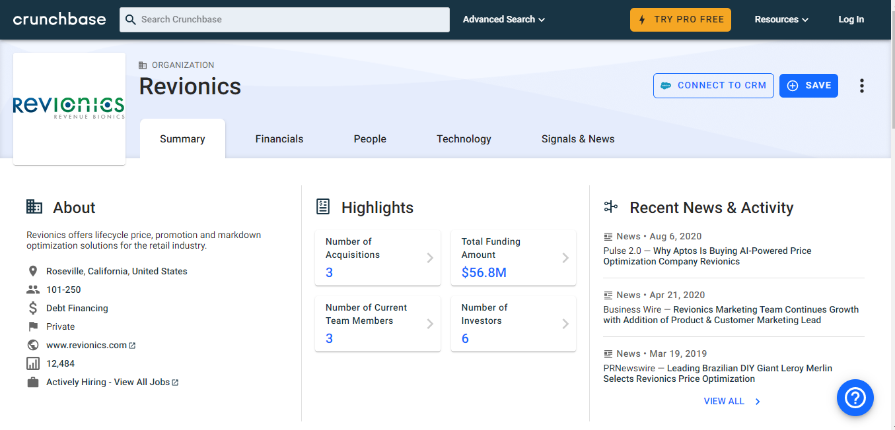

The business card company that I have chosen is Vistaprint

